BPC Meeting February 6th at 10am
Virtual: https://hartfordhealthcare.zoom.us/j/5910185257?omn=94757896050
Attendees: Cecile Serazo, Caitlin Geaghan, Jenn Jacobsen, Brittany Whiteley, SueEllen
Meeting called to order at: 10:02
News and Celebrations!
- Vote to approve BPC January Meeting Minutes
  - Cecile approved
- Caitlin Geaghan presents Adult Alcohol Program PowerPoint- 15 minutes
  - Since such a small group, she will present again in March meeting
  - She is working on an adult alcohol misuse grant through Amplify (funded through DMHAS)
  - Identify and address unmet health prevention needs across CT- they discovered Adult alcohol use biggest issue
    - Selected Bolton, East Windsor and East Hartford due to existing relationship with PFS
    - Priority: Men, first responders (primary) and women
      - Bolton event planned with fire department
        - Cecile mentioned a monthly meeting (last Monday of the month 7pm) where Caitlin could have a presence/table. There is also a weekly drill.
      - Cecile mentioned health department, Amplify meeting for various departments in the town in May
    - Outreach events planned: events, social norming campaign, and other
    - What we can do to help: attend trainings, recommend local resources, attend statewide conferences (April 1 save the date), recommend/make connections in the community
- Sam Forbes presents LPC PowerPoint—What is an LPC? Roles & Responsibilities
  - Will postpone presentation until the March meeting
- Youth Coalition—Recruitment, promotional items
  - Beginning to recruit. Molly Martin will be the new Bolton youth peer advocate. She will table during at lunch in the schools to build the youth coalition. This will support the LPC and the PFS grant. Brittany purchased and shared promotional items when tabling.
- SOR Grant proposal—Due 2/14/25
  - Up to 5k, Brittany will be working on it. It’s due next Friday, so not a lot of time to take considerations of LPC. Ashely mentioned lock boxes so they will add that in to the proposal. Cecile agreed lock boxes are great and no other ideas shared. Brittany will keep up updated.
- Charhouse Bakery: In person evening event February 12th 6pm (snow date 2/13)
  - Brittany would like to push it out another month for additional interest, but will check in with Ashley.
- Jen Jacobson—March Spotlight Speaker
  - Confirmed- reviewing the SPF and possibly Roberts Rule of Order
  - March 6
- Donate to Project Graduation?
  - Approved to donate money to Project Graduation and table during the event
  - Cecile approved
- Drunk Busters 6-Pack Goggles | Shop 6-Pack of Drunk Goggles
  - Activity for alcohol prevention using LPC funds to use in schools, community events, etc.
  - Youth coalition can assist with event with goggles
  - Possibly include the cannabis goggles with other funding sources
- Unseen Obvious Presentation
  - Amplify created a similar program to Hidden in Plain Sight. There are 4 backpacks. Some contain substance use paraphernalia and others don’t. Information on what parents should look for will be included. Additional substance use prevention will be handed out. See image below
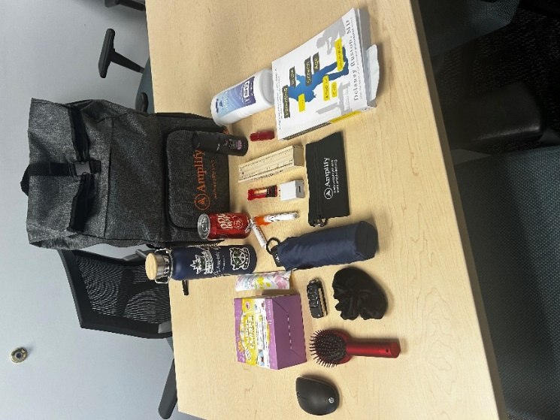
- Unseen Obvious Brochure- Information on LPC, Talking tips, Unseen Obvious, and Teen substance use prevention, cessation and resources
  - Will roll out in each town starting with East Hartford
  - Brittany will send all materials out to the LPC

