Bolton Prevention Council
November 7, 2024
Agenda
Meeting Zoom link: https://hartfordhealthcare.zoom.us/j/5910185257?omn=93740593667

- Trunk or Treat success- Suellen, Jordyn, Kari
- Integrating into Bolton schools
a. Met with Bolton Project Graduation: Brittnay will partner with them in funding or promotional items. Hosting at Spare time in Vernon
b. Plan to meet with Stephanie & Amy from BHS—meeting in Nov. To discuss partnership utiling LPC funds and PFS dollars
- Youth Voice Count - Can we use the data. YES! Permission granted
- Festival of Trees - December 6-7— Volunteers Needed
-Ashley will sign-up for BPC
-pick a set-up day Mon-Fri Dec 3rd 9-1pm—Amplify
-Asley will take care of the take down
- Winter Faire - December 7th – Registration and Volunteers Needed
One more week to sign up!
- Highlights from our social media.
- Formalize Structure of Council Leads: Survey
- In Person Quarterly meetings.
- Discuss Books at Town Hall - Who is going to oversee that?
- Meeting dates for 2025.
- Other matters:
a. Join Bolton Bulletin
b. Set up positions for each member:
https://forms.office.com/r/nxRd8fHfwX

Next Meeting- Thursday, December 5 at 10 a.m. via Zoom
( With Sam Forbes to discuss the LPC application process.)

PACKET
1 ) - Trunk or Treat success- Suellen, Jordyn, Kari

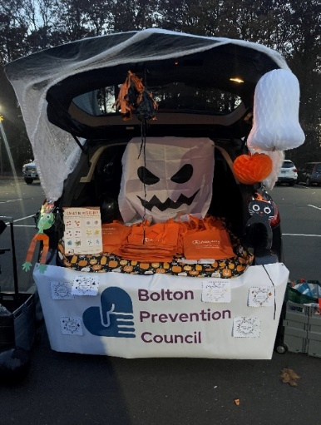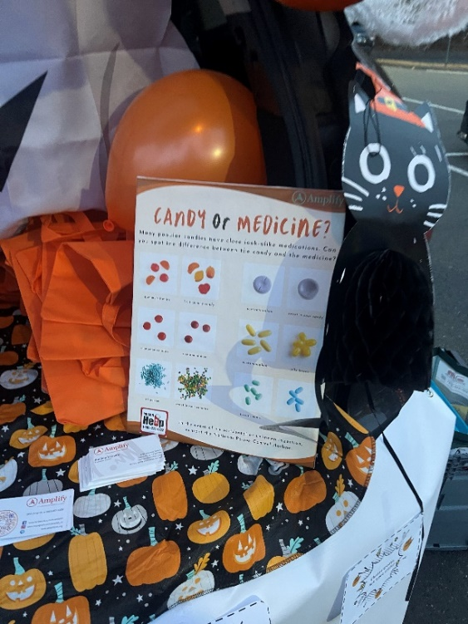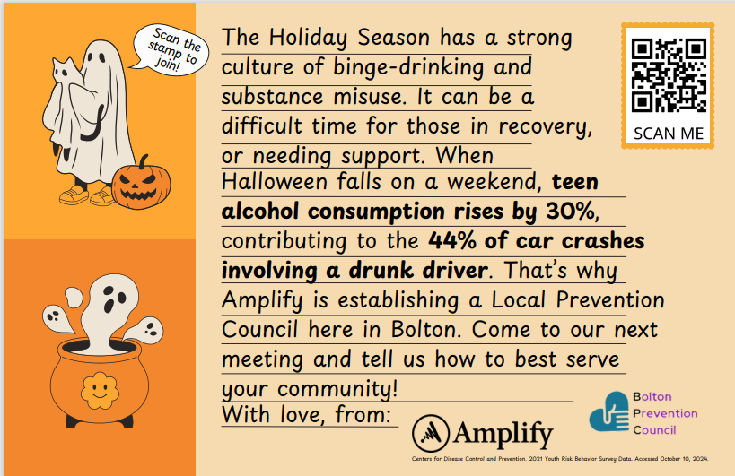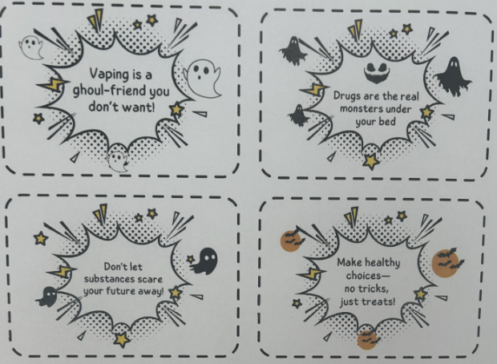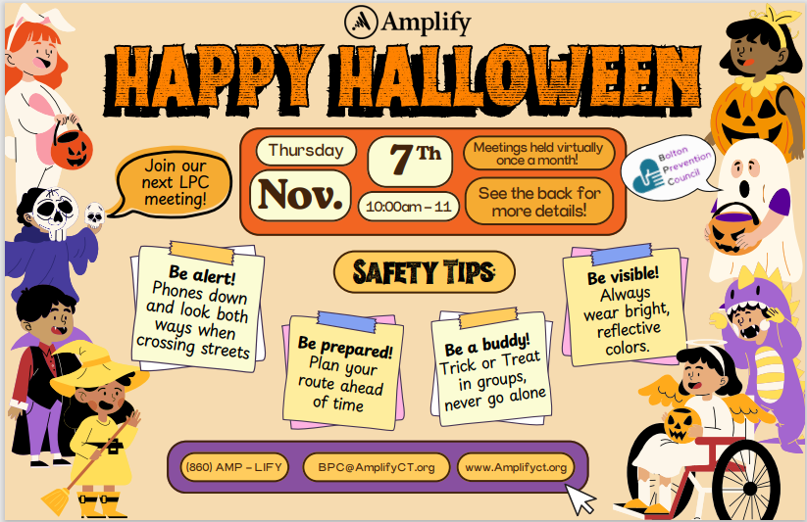

4- Festival of Trees
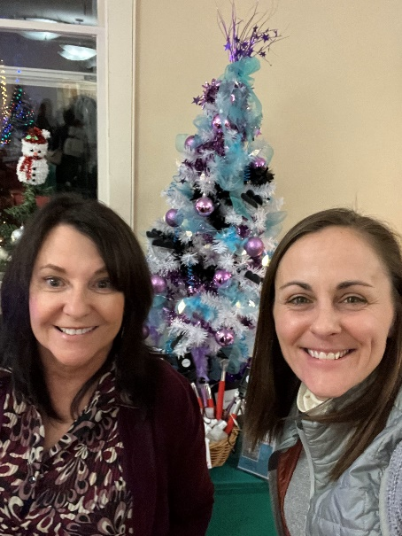

5) Winter Faire December 7th—We need volunteers
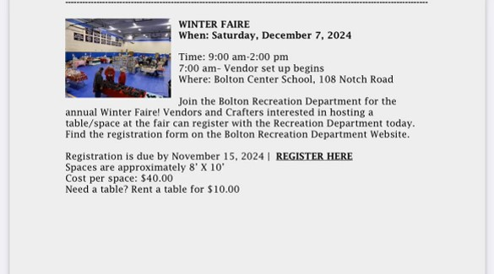

6) Highlights from our social media—Suellen
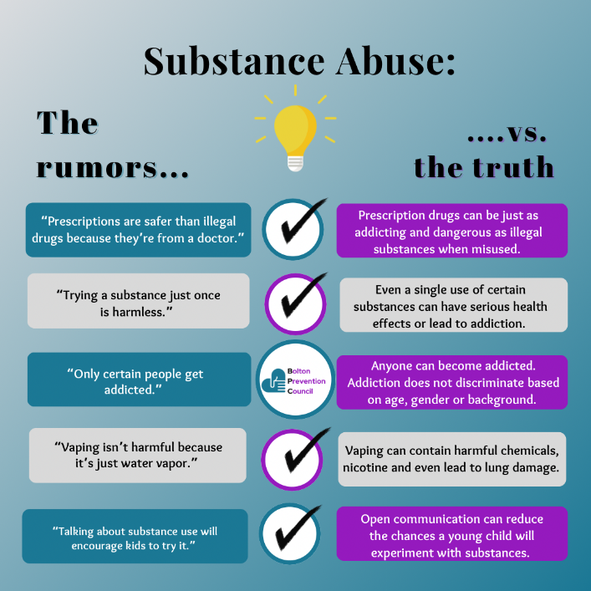

11) Set up duties for each member

- 1. President:
- Lead meetings, works with facilitator and vice chair to prepare meeting agendas (due to facilitator no later than 48 hours before each meeting), serves as LPC spokesperson, assists facilitator with grant reporting documents.

2. Vice President:
- Leads meetings in Chair’s absence, serves as a spokesperson as needed, assists with Chair’s duties.

3. Secretary:
- schedules meetings and reserves meeting space, takes meeting attendance, takes meeting minutes (and submits meeting minutes to facilitator no later than 48 hours after meeting), maintains LPC records.

4. Treasurer:
- manages the budget for the LPC grant and ensures funds are used as approved within the grant guidelines, provides financial updates at meetings and when requested, contributes financial data for grant reporting, works with facilitators to obtain vendor documents for payment

5. Grant Writer:
- Research and identify potential grants, focusing on sources like the CDC, CADCA, and state programs. Write and submit strong grant applications, helping secure ongoing funding for the council.

6. Training Coordinator:
- Identify training opportunities, both virtual and in-person, that would benefit council members. Set up and coordinate training schedules, sharing details with attendees. Distribute any useful materials or resources to team members after each session.

7. Events Coordinator:
- Help plan and execute council events that align with prevention goals.
Stay updated on local events and ensure LPC is represented when appropriate.
Act as an ambassador for LPC at events, connecting with the community and sharing what we do.

8. Social Media/Graphic Designer (Vanessa & Suellen):
- Design and post social media content to inform and engage the community about LPC activities. Develop posts that encourage interaction and raise awareness.
Make sure all content aligns with LPC’s mission and visual style.

9. Website Content Creator:
- Assist in keeping the website up-to-date with relevant information and resources.
Create a weekly article or blog post to keep content fresh and engaging.
Develop content that educates the community on prevention topics and enhances our online presence.

