Bolton Prevention Council
December 5, 2024
Agenda
Meeting Zoom link: https://hartfordhealthcare.zoom.us/j/5910185257?omn=93740593667

- LPC Application Process with Sam Forbes:
- How to fill out the LPC quarterly report.
The importance of establishing roles within our LPC.
- Festival of Trees - December 6-7— Volunteers Needed?
- Winter Faire – Saturday, December 7th – set up at 7 am until 2 pm
- Member position | Survey Results.

- Sam Forbes will present at our next LPC meeting—Establish roles (Phase 1)
  - Possible second meeting in January to discuss phase 2
- Vicky will send out Social Norm Data Pts. Please review. We will discuss data briefly at our January meeting.
- Jordyn will reach out to Psychology & Allied Health Students and Professors at ECSU to help recruit.
- Ashley will reach out to certified psychology individuals within the town of Bolton to help with recruitment.
- Cailtin sent contacts for Bolton groups/individuals
- Brittany & Cailtin will create a living document for the BPC to add for
  - Recruitment
  - Upcoming Events
  - Possible meetings with Partners
- When we meet with BHS staff next week, ask about getting access to AP psychology students and students who are thinking about attending college for Psychology, Health, Health Sciences, Community Building. So, we can start to establish a Youth Coalition.
- Switch our January meeting from 1/2/25 to 1/9/25—same time and place.
- In person social/meeting for late February/early March.
  - What can we do for you?
  - Mental Health of kids
  - Who are we—8-10 slides
  - Provide dinner
  - Discuss data from the YVC survey
- Brittany will reach out to the Boys & Girls Scouts, as well as the Y program for kids in Bolton.
- Ashley will reach out to the therapy practice in Bolton.
- Kari? & Jordyn will volunteer at the Winter Faire
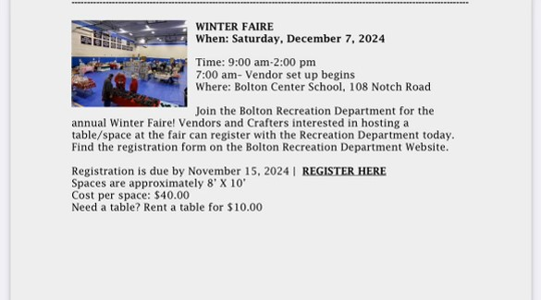
- Other?

